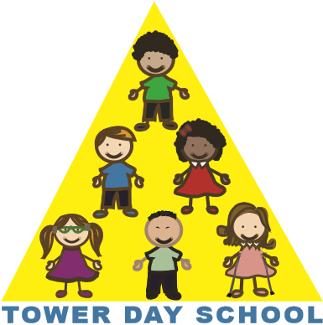

Tower Day School

Application Form

2023/2024

Child’s Name: _______________________________________________________________

Date of Birth: _______/______/__________ Sex: M_______F_______

Parent’s Name: ______________________________________________________________

Home Address: ______________________________________________________________
Street Town Zip

Phone: __________________________email: ______________________________________

Name(s) of sibling(s) who have previously attended Tower Day School:

_________________________________ ________________________________

Please number your class choices in order of preference.

3 year-old class options

___ T,TH class (8:30 - 11:30)

___ M,W,F class (8:30 - 11:30)

4 year-old class options

___ M,W,F class (8:30 - 11:30)

___ M-F class (8:30 – 11:30)

___ M,W,F FULL DAY class (8:30 - 2:30)

___ T,W,TH FULL DAY class (8:30 - 2:30)

Transition class

___ M,W,F (8:30 - 11:30) and T,TH (8:30 - 2:30)

___ Yes, I have read the attached application information.

Signature____________________________________________Date____________________

~Please return this form along with a $75.00 application fee~
~one fee per family/non-refundable*~
Please make checks payable to: Tower Day School

*Your $75 application fee is refundable if we cannot offer you one of your class choices. However, your application fee is non-refundable if can accommodate any one of your choices and you decide otherwise.

5 Summer Street, Lynnfield, MA 01940 towerdayschool@gmail.com 781.334.5576 www.towerdayschool.org

